Using Large Language Models to Justify Product Recommendations

**Benedict E. Brunker**

**University of Technology Sydney**

**42913: Social and Information Network Analysis**

Author Note

Include any grant/funding information and a complete correspondence address.

Abstract

The abstract should be one paragraph of between 150 and 250 words. It is not indented. Section titles, such as the word Abstract above, are now to use bold heading format. References, Footnotes, and Figure section titles should also be written in bold. To do this, use the **Section Title** style. This style automatically starts your section on a new page, so you don’t have to add page breaks. Note that all of the styles for this template are available on the **Home** tab of the ribbon, in the Styles dropdown menu.

Keywords: Add keywords here.

# Using Large Language Models to Justify Product Recommendations

Large Language Models (LLMs) have transformed the academy and wider society since the introduction of Generative Pre-trained Transformers (GPTs) (Radford et al., 2018) precipitated a revolution in natural language understanding and generation.

This paper explores possibilities for the use of LLMs in generating customized user *tips* or *justifications* for recommendation systems. We integrate LLMs into the architecture of a traditional recommendation system by collating information most relevant to the recommendation and using it to prompt an LLM to generate a tip that specifically addresses *why a particular user* is recommended a *particular product.*

# Previous Work

Ni, Li & McAuley (2019) used *Language Models* (LMs) to generate *recommendation justifications* by extracting “review segments which justify users’ intentions”. They distinguished recommendation *justifications* from *tips,* “a form of *explanation* as to why a recommendation might match a user’s interests” (p.1), which had been the focus of earlier work. This work was published before LLMs had become widely available for practical use, which motivated us to explore whether richer justifications could be generated by the current generation of freely available LLMs.

He et al. (2024) used LLMs to generate text attributes that could enrich the feature sets of Text-Attributed Graphs (TAGs) and thereby improve the performance of graph-based models like Graph Neural Networks (GNNs). The authors prompted LLMs to classify academic papers in citation network datasets. They then encoded the LLMs’ classifications and their *explanations* of their classifications into features that could be combined with other structural network features as inputs for a GNN. This combined approach proved more powerful than either classification with LLMs alone or GNN classification.

References

Last Name, A. B. (Year). Article Title. Journal Title, Pages #-#. URL. URL.

Last Name, C. D. (Year). Book TitleBook Title URL.

Last Name, D. E., Last Name, F. G. (Year). Report TitleReport Title URL.

Last Name, H. I. (Year, Month Day). Article Title/Headline. Periodical.Periodical.

Organization Name. (Year, Month Day).Webpage Title. URL.

Footnotes

1For APA reports, add footnotes manually on their own page following references. Do not use the **Insert** **Footnotes** method on the **References** tab as they will not be formatted correctly. For APA formatting requirements, it’s easier to type your own footnote references and notes. To format a footnote reference, select the number and then, on the **Home** tab, in the **Styles** gallery, click **Footnote Reference**. The body of a footnote, such as this example, uses the **Normal** text style. If you delete this sample footnote, don’t forget to delete its in-text reference at the end of the sample Heading 2 paragraph on the first page of body content in this template.

Tables

Table 1

Table Title

|  |  |  |  |  |
| --- | --- | --- | --- | --- |
| Column Head | Column Head | Column Head | Column Head | Column Head |
| Row Head | 123 | 123 | 123 | 123 |
| Row Head | 456 | 456 | 456 | 456 |
| Row Head | 789 | 789 | 789 | 789 |
| Row Head | 123 | 123 | 123 | 123 |
| Row Head | 456 | 456 | 456 | 456 |
| Row Head | 789 | 789 | 789 | 789 |

Note: Place all tables for your paper in a tables section, following references and footnotes. Start a new page for each table, include a table number and table title for each, as shown. All explanatory text appears in a table note that follows the table, like this one. Use the **Table/Figure** style, available on the **Home** tab, in the **Styles** gallery, to get the spacing between table and note. Tables in APA format can use single or 1.5 line spacing. Include a heading for every row and column, even if the content seems obvious. A default table style has been set up for this template that fits APA guidelines. To insert a table, on the **Insert** tab, click **Table**.

Figures Title

Figure 1.

Include all figures in their own section, following references, footnotes, and tables. Include a numbered caption for each figure. Use the Table/Figure style for easy spacing between figure and caption.

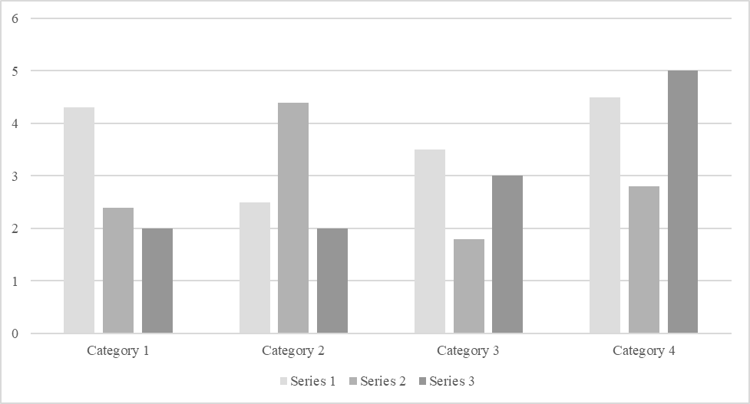

*For additional information on APA Style formatting, please consult the* [*APA Style Manual, 7th Edition*](https://apastyle.apa.org/style-grammar-guidelines)*.*